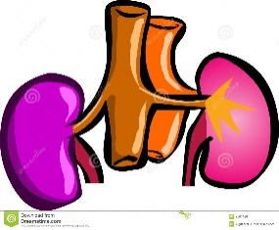Name: Quang Huynh

**Getting to Know your Kidneys**

Urinary Overview

Metabolism of nutrients by body cells produces various *wastes* such as carbon dioxide and nitrogenous wastes (creatinine, urea, and ammonia), as well as imbalances of water and essential ions. The metabolic wastes and excesses must be eliminated from the body. Essential substances are retained to ensure proper body functioning.

Although several organ systems are involved in excretory processes, the **urinary system** bears the primary responsibility for removing nitrogenous wastes fromthe blood. In addition to this purely excretory function, the kidneys maintainthe electrolyte, acid-base, and fluid balances of the blood. Thus, kidneys aremajor homeostatic organs of the body.

**Peristalsis** **Urethra** **Acid/Base**

**1½ Water** **8** **Kidneys**

**Urinary bladder** **Nitrogenous** **Ureters**

Part 1: Fill in the blanks

Nitrogenous 1.

Water 2.

Acid/base 3.

Kidney 4.

Ureter 5.

Peristalsis 6.

Urinary bladder 7.

Urethra 8.

1.5 9.

8 10.

The kidney is referred to as an excretory organ because it excretes (1) wastes. It is also a major homeostatic organ because it maintains the electrolyte, (2) , and (3) balance of the blood. Urine is continuously formed by the (4) and is routed down the (5) by the mechanism of (6) to a storage organ called the (7) . Eventually the urine is passed to the body exterior by the (8). In males, this tube-like structure is about (9) inches long; in females, it is approximately (10) inches long.

11. **Where are the kidneys located (specifically)?**

The kidneys are located underneath the ribcage and on each side of the spine.

12. **Describe kidney structure.**

The kidneys are a pair of bean-shaped organs in the renal system of your body.

13. **What is the function of the ureters and urethra?**

The function of the ureter is to bring urine from the kidneys to the bladder. Then, the urethra allows the urine to go out of the body through a tube.

Part 2: Coloring

The diagram shown is an anterior view of the entire urinary system. Select different colors for the following organs and use them to color the coding circles and the corresponding organs on the figure.

○ Kidney ○ Bladder ○ Ureters ○ Urethra

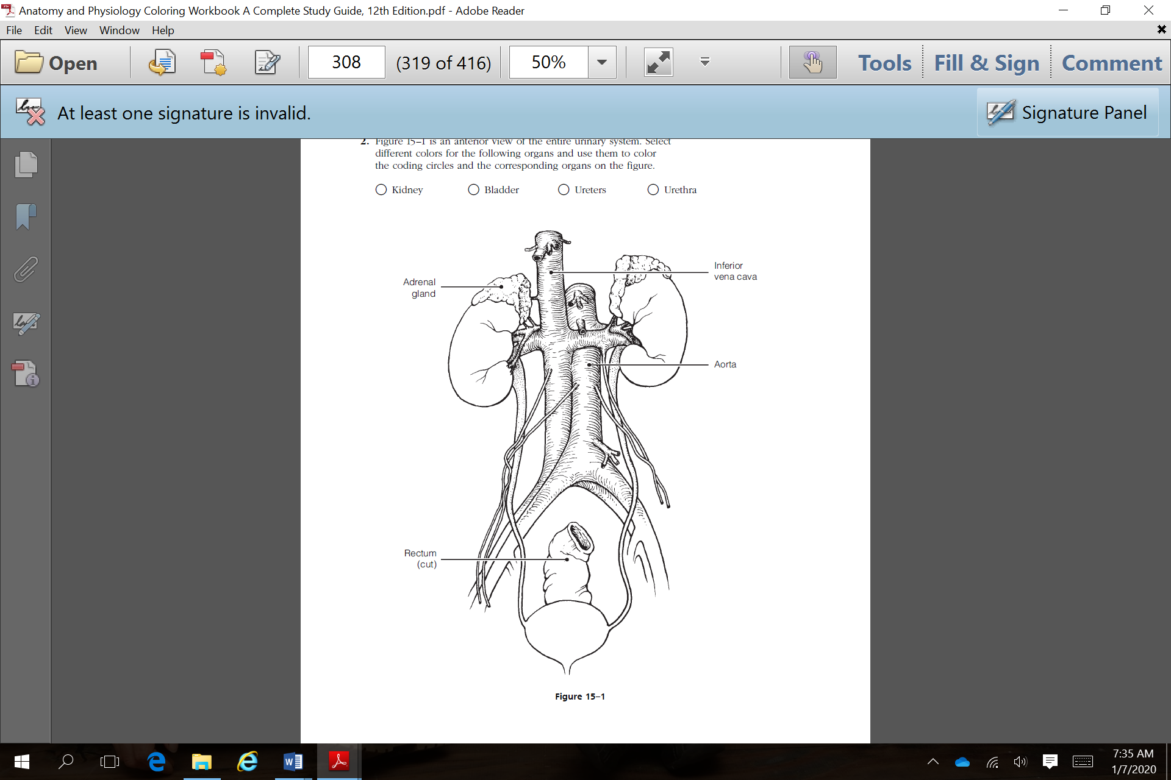



Kidney Overview:

An adult kidney is about 12 cm (5 inches) long, 6 cm (2.5 inches) wide, and 3 cm (1 inch) thick, or about the size of a large bar of soap. Your kidneys remove wastes and extra fluid from your body. Your kidneys also remove acid that is produced by the cells of your body and maintain a healthy balance of water, salts, and minerals—such as [sodium](https://www.niddk.nih.gov/Dictionary/S/sodium), [calcium](https://www.niddk.nih.gov/Dictionary/C/calcium), [phosphorus](https://www.niddk.nih.gov/Dictionary/P/phosphorus), and [potassium](https://www.niddk.nih.gov/Dictionary/P/potassium)—in your blood.

Without this balance, nerves, muscles, and other tissues in your body may not work normally.

Your kidneys also make hormones that help

* control your [blood pressure](https://www.niddk.nih.gov/Dictionary/B/blood-pressure)
* make [red blood cells](https://medlineplus.gov/ency/anatomyvideos/000104.htm)
* keep your bones strong and healthy

Each of your kidneys is made up of about a million subunits called nephrons. Nephrons are the structural and functional units of the kidneys and are responsible for

forming urine.

Part 3: Labeling

14. Label the missing parts from the cross section of the kidney shown. Terms provided.

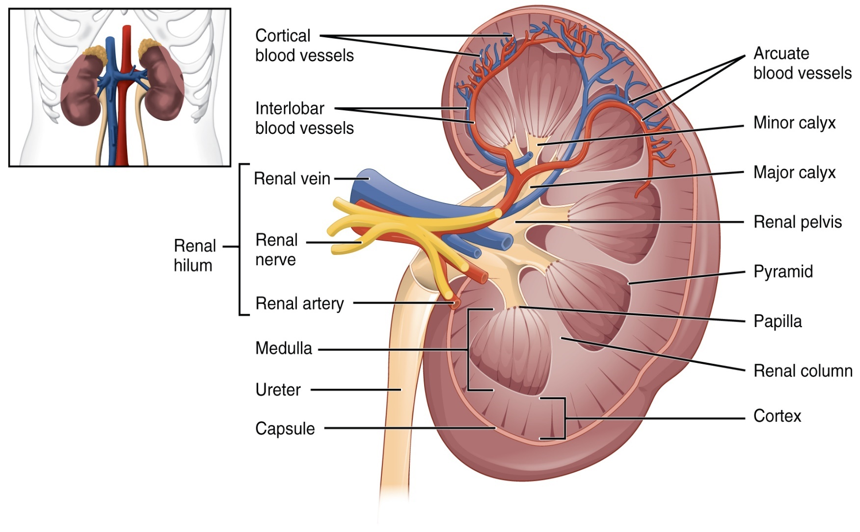

Minor calyx

Renal cortex

Hilum

Renal pyramid

Renal medulla

Renal column

Ureter

Renal cortex

Fibrous capsule

Renal pyramid

Fibrous capsule

Minor calyx

Renal pelvis

Renal column

Hilum

Renal medulla

Ureter

Renal cortex

15. **The renal pyramids are separated from each other by extensions of the renal cortex called renal columns**

1. renal medulla
2. minor calyces
3. medullary cortices
4. **renal columns**

16. **The right kidney is slightly lower because it is displaced by the liver.**

1. **it is displaced by the liver**
2. it is displaced by the heart
3. it is slightly smaller
4. it needs protection of the lower ribs

17. **What anatomical structures provide protection to the kidney?**

The kidneys are protected by the ribs and fat surrounds the kidneys for further protection.